Machine Problem 1(Python) Screenshots:

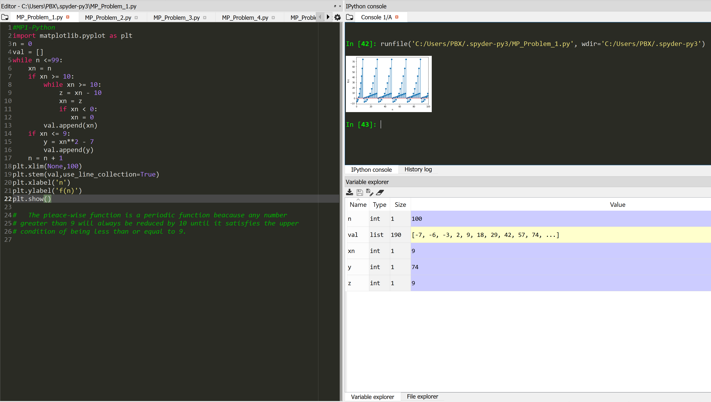

Picture Code Testing

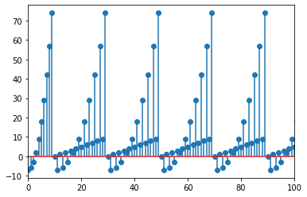

Figure The Resulting Plot